holidays
tra roam
Treasures of the Nile

EGYPT
13 Days

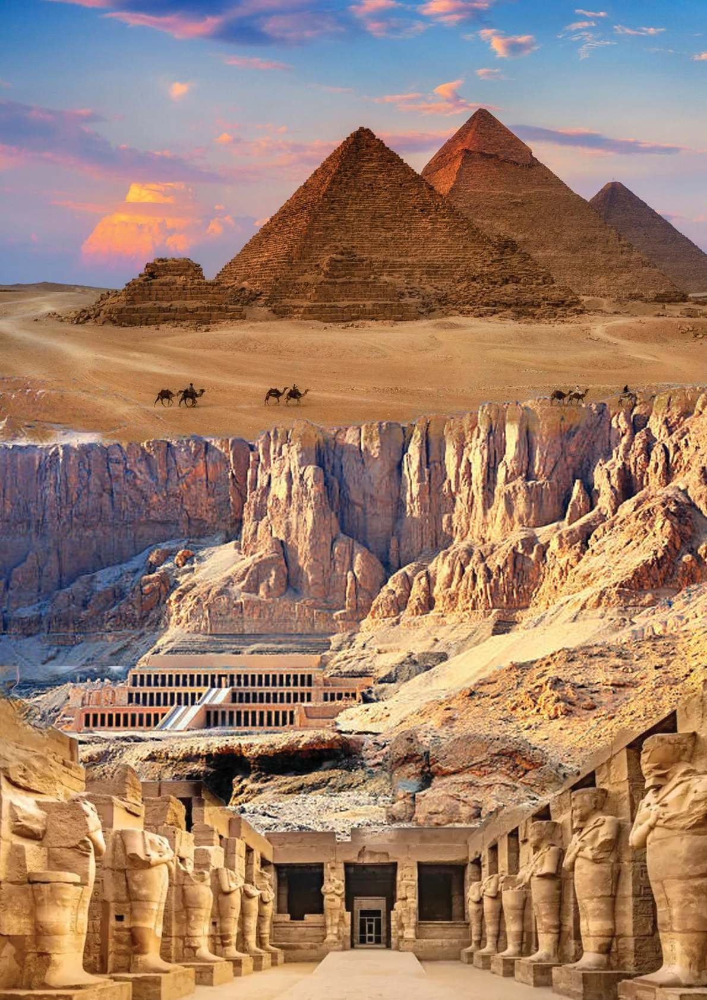










Group Departures
08th Dec,
2025

Special Inclusions - Tutankhamen’s Tomb

-: Places to be Covered :-
Cairo Saqqara
Memphis Abu Simbel
Alexandria Aswan
Edfu Luxor
Hurghada Valley of the Kings
Faiyum Oasis
Special Attraction
[Tutankhamun’s Mummy at Valley of Kings]

-: Overview :-
As one of the largest and most iconic wonders of the world and a “must visit” travel destination, Egypt is a location that should be on every adventurer’s list – and our Egypt holidays can help you tick it off.
Pyramids rise above sun-baked sands. The Sphinx stares, unblinking, into a relentlessly blue sky. Boats wend their way down the waters of the Nile. Traders hawk their wares in the dusty bazaars. In many ways, Egypt seems timeless, unchanging.
Throughout history, its cultural wonders have attracted travellers, archaeolo gists, and treasure hunters, from the famous sites of ancient Thebes and As wan to the mighty architectural feats of Cairo. Our Egypt tours are shaped by the country’s glorious past; you will learn all about the pharaohs and marvel at the Pyramids, with Trip Makerz you could also be cruising along the Nile in a spectacular five-star boat, exploring the less-visited temples of Upper Egypt or sailing a traditional felucca. When you board one of our exquisite cruises on your trip to Egypt, you will experience an array of sights like no other. As we travel upstream together, you’ll be able to watch the locals go about their normal daily lives as well as visit the breath-taking Edfu and Kom Ombo temples. With lush green banks and stunning sunsets over the Nile, this adventure holiday in Egypt is an unforgettable experience

-: Daywise Itinerary :-



DAY KOLKATA TO CAIRO
1 Today you begin your journey by boarding your outbound flight to Cairo.
[Meals on Board]


DAY ARRIVE CAIRO
2 Upon arrival in Cairo in the morning complete immigration and customs formalities. Then proceed
for Egyptian Museum which contains relics dating back to 4000 BC. Here is a unique opportunity to survey the many fabulous treasures of Egypt in one place. Later enjoy Lunch. After lunch check in to the hotel. Evening enjoy sound and light show at the Pyramids. Overnight in Cairo.
[Meals on Board, Lunch & Dinner]


CAIRO – ALEXANDRIA – CAIRO DAY
After breakfast leave for a Full Day tour to Alexandria. Founded by Alexander the Great in 331BC, the 3 city was home to the Lighthouse of Alexandria, one of the Seven Wonders of the Ancient World. Our tour begins with a visit to The Catacombs of Kom El Shoqafa one of the largest Roman burial sites in
Egypt. Pompey’s Pillar which is an incredible granite Roman triumphal column made between 298-303 AD to pay homage to the great Roman Emperor Diocletian. Finally visit on a low plateau east of central Alexandria overlooking a beach on the Mediterranean Sea. After tour return to Cairo.
[Breakfast, Lunch & Dinner]


DAY GREAT PYRAMIDS – SAQQARA – MEMPHIS – ASWAN (By Overnight Night Sleeper Train)
4 After breakfast we begin our day with a visit to the Pyramids at Giza. Home to the Great Pyramids of
Cheops, Chephren and Mykerinos and the enduring and mysterious Great Sphinx. Later continue to visit the Saqqara area, where the stepped pyramid of Djoser is situated. This pyramid is significant because it was the first model for all the pyramids that came after it. Then we visit Memphis, where the statue of Ramses II is situated. Later evening we transfer to the railway station and board our first class sleeper train to Aswan. Dinner and overnight on board.

[Breakfast, Lunch & Dinner on Board] ASWAN – BOARDING NILE CRUISE DAY
We will detrain in Aswan in the morning. In ancient times, the town was legendary as the entrance 5
to the kingdom of Nubia. Today it's still something of a frontier town. With its mixed population of
Egyptians and Nubians, Aswan is quite unlike any other town in the country, and a fascinating place to visit. We begin with the visit to Philae Temple which was relocated by UNESCO to Aglika Island after it became evident that the original site of Philae would submerge on completion of the Aswan High Dam. It represents a magnificent and enduring testament to both ancient and modern engineering. After the tour, check in to your 5 Star Nile Cruise. Later in the day, we enjoy a sunset sail on a felucca, a traditional wooden sailing boat. Feluccas have been a fixture on the Nile River for centuries and are used in the protected waters of the Red Sea and eastern Mediterranean. The Felucca’s deck is strewn with soft colourful cushions and rugs and equipped with a canopy that offers shade and protection.
[Breakfast on Board, Lunch & Dinner]
DAY ASWAN – ABU SIMBLE – ASWAN – CRUISE CONTINUES
6 Today we visit Abu Simbel, 300 km. to the south through the Nubian Desert near the Sudanese
Border. This tour will start at 04:00 hrs in the morning. A breakfast box is provided. Built by Ramses II the two temples are certainly some of the most spectacular in Egypt. Originally on the banks of the Nile, the temples were raised to a new site above the lake in the late 1960s, as the waters from the new Lake Nasser rose behind the Aswan High Dam. The four great seated statues of Ramses II stare east towards the rising sun. Later return to Cruise. Sail to Kom Ombo. The Temple of Sobek and Haroeris at Kom Ombo was dedicated to the crocodile god (Sobek) and falcon god (Haroeris). Later continuing our journey to Edfu which is where we will spend the night.

[Breakfast, Lunch & Dinner]
EDFU – ESNA LOCK – LUXOR – CRUISE CONTINUES
DAY


Waking in Edfu, we start our day exploring the best-preserved cult temple in Egypt, Horus Temple in 7
Edfu before sailing further north along the Nile. After crossing the Esna lock we reach our destination
Luxor, where we will have our final dinner on board and hopefully witness a stunning sunset over the river.
[Breakfast, Lunch & Dinner]
DAY LUXOR – HURGHADA
8 After breakfast we disembark in Luxor and start our day visiting the Valley of the Kings. For nearly
500 years this was the site of royal burials and it contains the tombs of over 62 pharaohs. You will enter to Tutankhamen’s Tomb which is included to our itinerary. After wards we visit the massive stone statues of the Colossi of of Memnon, then to mortuary Temple of Queen Hatshepsut, which was built by the architects of the New Kingdom Pharaoh Hatshepsut approximately in the 15th century BC. After Lunch, we visit the extraordinary Karnak and Luxor temples which both stand within the modern city of Luxor. Later we leave behind the green Nile valley and drive through the barren Eastern Desert to the Red Sea (approx. 5 hours). Our destination is Hurghada, a vibrant beach resort ideally located for activities out at sea. Overnight in Luxurious resort in Hurghada.
[Breakfast, Lunch & Dinner]

HURGHADA
DAY
9
Today the day is free to relax or enjoy the many optional activities in the area. (Optional tours to experience the exquisite diving and snorkeling among the Red Sea coral reefs and see some amazing rare fish. Or choose one of the many other activities such as windsurfing, sailing and deep-sea fishing) Overnight in Hurghada.
[Breakfast, Lunch & Dinner]

DAY HURGHADA – CAIRO
10 After breakfast we drive back to Cairo. On reaching Cairo explore the old bazar of Khan-el-Khalili

which is a great place to shop for souvenirs. The stalls are full of colourful lanterns, candles, jewellery, perfumes, musical instruments, and other handicrafts where you can pretty much find anything you could possibly want within its walls. Overnight stay at Cairo.
DAY
11

[Breakfast, Lunch & Dinner]

CAIRO – FAIYUM OASIS

After Breakfast, transfer to Faiyum Oasis. Faiyum is a city in Middle Egypt. Located 100 kilometres southwest of Cairo, discover the enchanting Faiyum Oasis, Egypt’s hidden gem with a rich history & natural beauty. Explore ancient ruins, enjoy lush landscapes, and relax in diverse accommodations. Unveil the secrets of this unique destination. Overnight stay at Faiyum Oasis.
DAY FAIYUM OASIS - CAIRO – FINAL DEPARTURE

12 After Breakfast, morning is free for your own till the airport transfer time. Later transfer to Cairo International Airport for the final departur to Kolkata.

[Breakfast, Meals on Board] ARRIVE KOLKATA

DAY

Tour Ends. Return back to home with everlasting memory of your Egypt Tour. 13

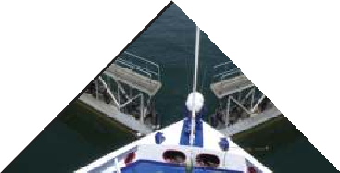
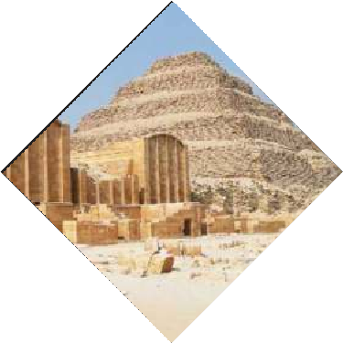
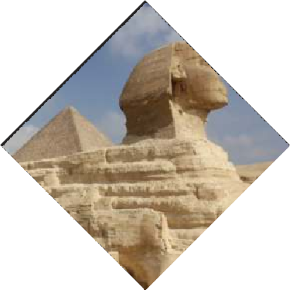
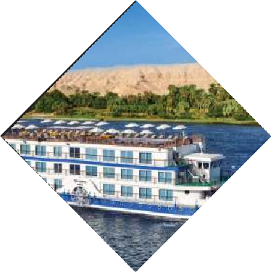
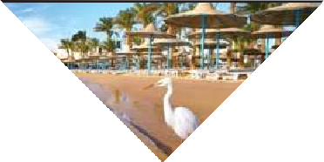
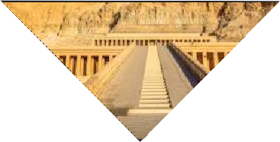
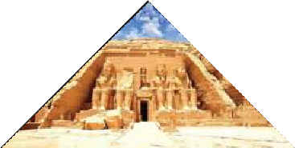
-: Package price :-
PRICE FROM
ADULT (TWIN/DOUBLE SHARE)
CHILD [2-11 Years]
WITH BED
CHILD [2-5 Years]
WITHOUT BED
SINGLE SUPPLEMENT
TRIPLE REDUCTION

KOLKATA

TBA

TBA

holidays
tra roam

-: Inclusions :-

Return Economy Class Air Ticket with Taxes Ex-Kolkata 4*/5* Hotels on Twin/Double Sharing basis
5* Deluxe Nile Cruise on Twin/Double Sharing basis
Daily meals as per itinerary
All Sightseeing & Entry Fees as per itinerary
All tours & transfers by Air-Conditioned/Heated Deluxe Coach One Way Train Ticket from Giza to Aswan in First Class Coupe English speaking local Guide services as per itinerary
All Taxes & Service Charges as mentioned in the itinerary Overseas Medical & Travel Insurance up to 60 years of age Visa Processing Charges
Tips for Overseas Tour Guides & Coach Drivers
Service of a Tour Manager from Kolkata throughout the tour

-: Exclusions :-
Government of India Goods & Services Tax (GST) of 5% TCS of 5% on total Tour Package (incl. of all taxes) Extra amount Insurance for 60 years and above
Any extra cost incurred due to illness, accident, hospitalization, or any personal emergency.
Any extra expense incurred due to any force majeure situation before Any extra expense incurred due to any force majeure situation before
Passport related services
Personal expense like porterage, laundry, telephone, shopping, alcoholic beverages, extra mineral water, or food which is not a part of group’s set meal plan,
Anything specifically not mentioned in the ‘package includes’ column. Any increase in Taxes if imposed by Airline/Govt./Visa Authorities

-: Disclaimer :-

The itinerary, tour price & hotels are subject to change under unavoidable circumstances without prior notice.

holidays
tra roam

-: Payment Terms :-

**Registration Fees: Rs. 50,000/- Per Person. Balance payable 6 weeks prior to departure.
N.B. All pricing is based on minimum group size of 20 adults and worked out as per rates available on 27th Jun 2025 which are subject to change without notice if such rates change prior to departure. Airfare & Airline is subject to change as per availability & due to situations beyond our control.

 ED-24, Rajdanga Main Road, E.K.T. Kolkata - 700107 www.travroamholidays.com

Prasanta 98300 73383
Shouvik 96742 83977
Debnath 98368 97872

Sonali 97481 32975
Mousumi 83349 02894




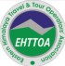
holidays
tra roam

