holidays
PRESENTS
SET YOUR FOOT ON
tra roam

Antarctica
An xpedition with Landings

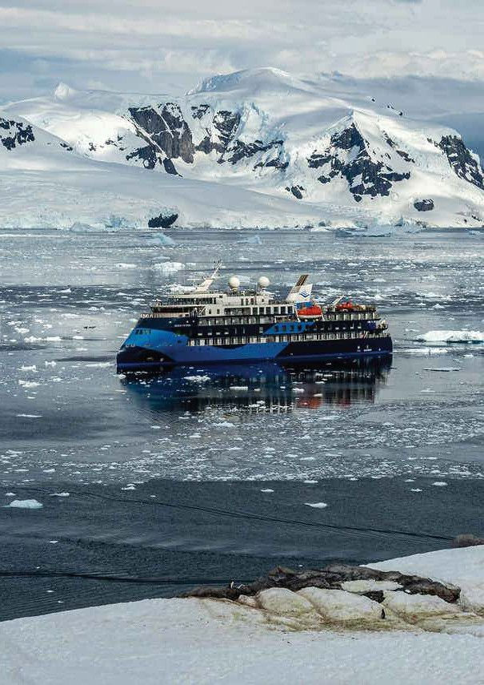


Group Departure
16th February
16 DAYS
2026

-: Detailed Itinerary :-

This is an expedition where the elements rule, and the weather, wind and ice conditions will determine our final schedule. Safety is paramount and the captain will decide the sailing itinerary during the voyage. Therefore, this itinerary is just an indication of what you can experience, and why every expedition with Ocean Albatros.

DAY ONE | KOLKATA TO MUMBAI
Welcome to the world of Travroam Holidays. Our experienced and pleasant Tour Manager, who will be with you throughout, will meet & greet you at Kolkata International Airport before journey via Mumbai. [ Meals on Board ]
DAY TWO | MUMBAI TO BUENOS AIRES
Your flight will reach Capital of Argentina in the afternoon/evening. After long flight overnight stay in Buenos Aires is the ideal setting to kickstart your adventure. Famously called the ‘Paris of South America’, Buenos Aires is a sensuous fusion of faded European splendour and Latin American panache. Spend the evening at your leisure, overnight in Buenos Aires.
[ Meals on Board, Dinner ]

DAY THREE | BUENOS AIRES TO USHUAIA
After a healthy & relaxing breakfast, we will fly Ushuaia. Ushuaia is a resort town in Argentina. It's located on the Tierra del Fuego archipelago, the southernmost tip of South America, nicknamed the “End of the World.” The windswept town, perched on a steep hill, is surrounded by the Martial Mountains and the Beagle Channel. It's the gateway to Antarctica.
[ Breakfast & Dinner ]

DAY FOUR | USHUAIA, ARGENTINA, EMBARKATION
Today we explore this vibrant Patagonian city.The island of Tierra del Fuego is a hiker's paradise with rugged snow-capped mountains, glaciers, flower-filled meadows and rich boggy wetlands. In the afternoon, we board our vessel, waiting to welcome us in port.
After our mandatory safety drill, our expedition begins as we navigate through the calm waters of the famous Beagle Channel (named for Charles Darwin's ship). This steep-sided strait divides southern Tierra del Fuego between Chile and Argentina, and has been the jumping-off point for thousands of expeditions into the unknown. Watch out for whales and dolphins as we sail off the edge of the map into the tempestuous Drake Passage.
[ Meals on Board, Dinner ]

DAY FIVE - SIX | AT SEA - CROSSING THE DRAKE PASSAGE SOUTHBOUND
As we sail through the renowned Drake Passage, linking Patagonia to the Antarctic Peninsula, brace yourself for its notoriously turbulent waters and fierce westerly winds, aptly called the Roaring Fifties. Thankfully, our purpose-built expedition vessels ensure a comfortable journey, with their uniquely stable X-Bow and powerful engines, guided by an expert crew. Embrace this exciting crossing, considered a badge of honour by seasoned sailors, as you traverse it twice during our expedition.
In the Drake Passage, our focus turns to preparing for our arrival in Antarctica. Your Expedition Leader
will provide thorough safety briefings and guidelines to minimise our impact on this pristine environment. Our dedicated Expedition Team will assist in biosecuring your gear while offering tailored lectures on Antarctic exploration, wildlife, and more.
On the third day, we'll cross the Antarctic Convergence, marked by a sudden drop in temperature as warmer currents give way to Antarctic waters. This transition fosters a surge in marine life, promising sightings of petrels, albatrosses, and possibly even penguins, seals, and whales. Weather permitting,
we aim to land on the South Shetland Islands on the afternoon of the third day of our expedition, starting our exploration of the Last Continent.
[ All Meals on Board]

DAY SEVEN - EIGHT - NINE | THE ANTARCTIC PENINSULA
Next, we venture further south along the Antarctic Peninsula into the Gerlache Strait region. This icy expanse requires meticulous planning by our Expedition Leader and Captain, who will plot a route to explore a variety of sites highlighting the area's staggering natural beauty.
The Gerlache Strait, consisting of the 'spine' of the Antarctic Peninsula and a large number of mountainous glaciated islands, offers a plethora of iconic Antarctic experiences. From Zodiac cruises in Paradise Bay, to witnessing penguins nesting on Cuverville Island, each potential stop promises awe- inspiring encounters. Explore historic huts at Damoy Point, witness humpback whales feasting on krill in Wilhelmina Bay, and marvel at the jaw-dropping scenery of the Lemaire Channel. Wherever we go on the Antarctic Peninsula, endemic wildlife, tantalising history and breathtaking natural beauty can be found at every turn.
While our exact destinations will depend on weather and ice conditions, your Expedition Leader will ensure guests are informed of our plans through nightly briefings. In the ever-changing Antarctic environment, flexibility is key as we adapt plans to suit the conditions. When not off the vessel exploring, our guests can enjoy enriching onboard experiences such as lectures, recaps, spa treatments, or simply soaking in the majesty of Antarctica from one of our comfortable lounges.
[ All Meals on Board]

DAY TEN | THE SOUTH SHETLAND ISLANDS
Our Antarctic odyssey culminates amidst the rugged beauty of the South Shetland Islands. This archipelago represents the northernmost tip of Antarctica, standing proud against the relentless force of the Southern Ocean. Despite the furious elements, the islands boast a remarkable richness of wildlife, with numerous colonies of Gentoo and Chinstrap Penguins dotting the island shores, accompanied by an array of formidable seabirds like the predatory Giant Petrels.
The ice-capped peaks of Livingstone, Greenwich, and King George Islands offer a stunning backdrop to explore. Experience the eerie landscape of Deception Island, an active volcanic crater with black steaming sands and rusting ruins, or witness the bustling penguin colonies on Aitcho and Half Moon Islands, or immerse yourself in the history of Yankee Harbour, once a vital anchorage for sealers.
As we bid farewell to the South Shetland Islands, we carry with us memories of their stark beauty and abundant wildlife, a fitting conclusion to our extraordinary Antarctic expedition.
[ All Meals on Board]

DAY ELEVEN - TWELVE | AT SEA - CROSSING THE DRAKE PASSAGE NORTHBOUND
We eventually depart Antarctica, and spend two days at sea on our way northwards back across the infamous Drake Passage towards the more welcoming shores of the Beagle Channel and Ushuaia, Argentina. During our time at sea, a variety of activities will be arranged on board to provide our guests with the chance to reflect on their voyage. Relax with an expertly crafted cocktail in the Nordic Bar in the company of new friends, soak up the knowledge and passion of our Expedition Team during lectures in the Shackleton Lounge, or simply enjoy the flight of the albatross which accompany us northwards.
During your last evening onboard, join the Captain and Officers for the Farewell Party, followed by a presentation of photos and video by our onboard photographer - the ideal opportunity to re-live your Antarctic adventure!
[ All Meals on Board]

DAY THIRTEEN | DISEMBARKATION AT USHUAIA AND BACK TO BUENOS AIRES
On the morning of the final day of our voyage, we will arrive back at the pier of Ushuaia, Argentina. Trees, grass and a busy city may seem strange to you after the white wilderness of Antarctica! After a hearty breakfast, it is time to bid a fond farewell to the Crew and Albatros Expedition Team, and descend the gangway back to dry land with memories of the voyage of a lifetime. We later transfer to Ushuaia airport to catch flight for Buenos Aires.
[ All Meals on Board & Dinner]

DAY FOURTEEN | BUENOS AIRES CITY TOUR AND FINAL DEPARTURE
After a healthy & relaxing breakfast, we will visit for City tour of the beautiful City of Maradona. We will try to cover House of famous Argentine writer Victoria Ocampo, Boca Juniors football club and many more like this. After completion of city tour we proceed to airport to board final flight to India.
[ Breakfast, Light Lunch & Dinner on Board ]

DAY FIFTEEN | IN THE SKY & A SMALL STOP IN ADDIS ABABA
After a long flight journey, we will arrive at Addis Ababa for a small layover. Then we will board a connecting flight to Mumbai.
[ Meals on Board]

DAY SIXTEEN | ARRIVE KOLKATA
Upon arrive in Mumbai, board flight for Kolkata. We will arrive in Kolkata by Evening. Tour Ends Here.

IMPORTANT INFORMATION
The Package Price is applicable if the group consists of 15 Adults minimum, at the time of final boarding.

*Imp: Weather, wind, ice and local conditions will determine the exact nature of your programme and schedule. Safety is paramount and the ship’s captain will decide the final sailing itinerary during the voyage. Therefore, every voyage is unique and all advertised routes, by the very nature of the region, can only be indicative.

-: Package price :-
PRICE FROM
ADULT (TWIN/DOUBLE SHARE)
SINGLE SUPPLEMENT
KOLKATA

TBA

-: ACCOMMODATIONS/ SIMILAR STANDARD :-

BUENOS AIRES : CRUISE :
4 & 3 STAR HOTEL
ALBATROS EXPEDITION CRUISE - Ocean Albatros

TEMPERATURE CHART – OUTSIDE THE CRUISE [In °CELSIUS]

NAME OF THE PLACE | MAX | MIN
BUENOS AIRES | 28 | 20
USHUAIA | 14 | 06
SCHOLLART CHANNEL & SOUTH SHETLAND | 05 | -04

-: Inclusions :-

Return Economy Class Air Ticket with Taxes Ex-Kolkata. 3*/4* Hotels on Twin/Double Sharing basis.
Meals as per itinerary.
All Sightseeing & Entry Fees as per itinerary.
Overseas Medical & Travel Insurance up to 60 years of age. Visa Processing Charges. (E-Visa Charges not included)
Service of a Tour Manager from Kolkata throughout the tour.

-: Exclusions :-
Government of India Goods & Services Tax (GST) of 5%
TCS 5% applicable on total tour Package (incl. of all taxes). Extra amount Insurance for 60 years and above
Any extra cost incurred due to illness, accident, hospitalization, or any personal emergency.
Any extra expense incurred due to any force majeure situation before Any extra expense incurred due to any force majeure situation before
Passport related services
Personal expense like porterage, laundry, telephone, shopping, alcoholic beverages, extra mineral water, or food which is not a part of group’s set meal plan,
Anything specifically not mentioned in the ‘package includes’ column. Any increase in Taxes if imposed by Airline/Govt./Visa Authorities
-: ON BOARD GENERAL INCLUSIONS :-
All Zodiac landings and excursions, as per itinerary, guided by our Expedition Team Expedition parka
Rubber boots loan scheme
Briefings and lectures by our Expedition Leader and Team English-speaking Expedition Team
Halal meat options available
Ladies-only hours in the sauna
Complimentary beverages at dinner (served at a-la-carte dinners) Free tea and coffee available 24 hours
Welcome and Farewell Parties

-: Disclaimer :-
The itinerary, tour price & hotels are subject to change under unavoidable circumstances without prior notice.

-: Payment Terms :-
**Registration Fees: Rs. 2,00,000/- Per Person. Balance payable 6 weeks prior to departure.
N.B. All pricing is based on minimum group size of 15 adults and worked out as per rates available on 1st August 2025 which are subject to change without notice if such rates change prior to departure. Airfare & Airline is subject to change as per availability & due to situations beyond our control.

ED-24, Rajdanga Main Road, E.K.T. Kolkata - 700107 www.travroamholidays.com

Prasanta 98300 73383
Shouvik 96742 83977
Debnath 98368 97872

Sonali 97481 32975
Mousumi 83349 02894





holidays
tra roam

