***holidays***

tra roam

# COASTAL CLASSICS

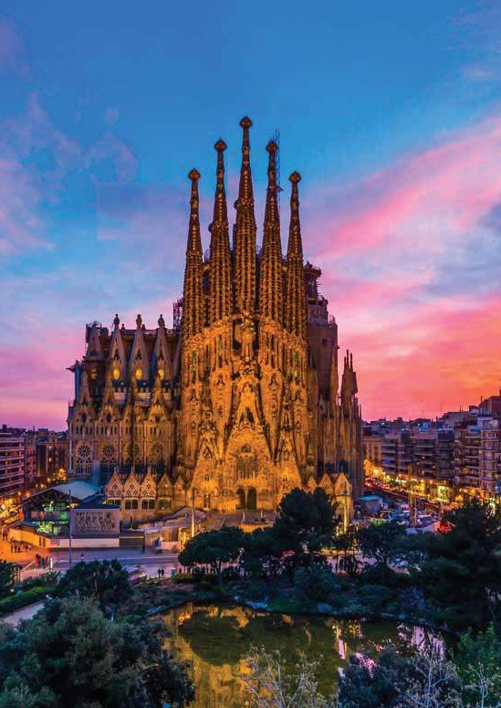

16 Days

**[Ex** **Kolkata]**

# Departure

**7th** **Oct** **2025**

 SPAIN

 PORTUGAL

## -: PLACES COVERED :-

Madrid, Avila, Salamanca, Seville, Cordoba, Granada, Valencia, Barcelona

Aveiro, Coimbra, Lisbon

 MOROCCO  Rabat, Casablanca, Marrakech

## -: Overview :-

Spain, Portugal & Morocco over the years have become increasingly popular destinations. Be it the ice beach bars, hardcore football fanfare, Gaudi’s jaw-dropping architecture, bizarre and quirky festivals, vibrant nightlife, feet-tapping flamenco, magnificent palaces, tapas bars, delectablecava and adventures galore, Spain is an exotic destination that is every party lover’s dream. Portugal,on the other hand, has the best clifftop castles, sand dune covered golden beaches, cobblestone villages, great food, scenic vineyards, and age-old music traditions making it the place for every food and beach lover. Discover the best of these fine European countries with Spain and Portugal tours and experience travel delight.

## -: Detailed Itinerary :-

**DAY** **KOLKATA** **TO** **CASABLANCA**

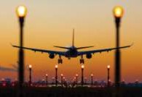

**1** Today you begin your journey by boarding your outbound flight to Barcelona.

**[** **Meals** **on** **Board** **]**

### ARRIVE CASABLANCA - MARRAKECH



**DAY**

**2**

Arrive Casablanca – business city of Morocco. Casablanca is a port city and commercial hub in western Morocco, fronting the Atlantic Ocean. The city's French colonial legacy is seen in its downtown Mauresque architecture, a blend of Moorish style and European art deco. Transfer to marrakesh, Upon arrival transfer to the hotel for check in & Dinner.

**[**  **Meals** **on** **Board** **&** **Dinner** **]**

**DAY** **MARRAKECH** **–** **CASABLANCA**



**3** After breakfast leave for the city tour of Marrakech. Marrakech is the second oldest mperial City and the

"Pearl of the South". Founded by the Almoravides at the end of the 11th century, Marrakech sits in a lush oasis nestling at the foot of the snow-capped Atlas Mountains. You will visit the Bahia palace, El Badi palace, Koutoubia Mosque(outside view), then Majorelle Garden etc. The city tour includes colorful souks and the famous Jemaa El Fna square always alive with curious people. After tour transfer to Casablanca, Check in, dinner and overnight at hotel.

**[**  **Breakfast,** **Light** **Lunch** **&** **Dinner** **]**

### CASABLANCA – RABAT

**DAY**

After breakfast check out from Hotel and proceed for Casablanca city tour. The city tour of Casablanca by **4**



covering the Great mosque Hassan II, the United Nations and Mohamed V squares, the Habbous district and the Aïn Diab corniche lined with its swimming pools and clubs. After the tour transfer to Rabat - “Imperial garden city”. Tour begins with the outside visit of the Royal Palace, walk they’re by the Mechouar, then go to La Tour Hassan and Mohamed V mausoleum, the visit will end with the Oudayas gardens, an ancient military building built for defensive purposes on high ground over the mouth of the Bou Regreg river and the Atlantic ocean. Dinner & overnight.

**DAY** **RABAT** **-** **TANGIER** **-** **ALGECIRAS**



**5** After breakfast leave for Tangier for Sightseeing. In this tour we will see Cape Spartel and Hercules Cave

After tour drive to Tangier Med Port then take a ferry for Algeciras. Arrive Algeciras port then transfer to hotel. Dinner & overnight.

**[**  **Breakfast,** **Light** **Lunch** **&** **Dinner** **]**

**ALGECIRAS** **-** **GRANADA** **-** **CORDOBA** **DAY**



After breakfast proceed to Granada - Andalucía’s splendid Moorish architectural heritage. Enjoy a guided **6**

tour of Granada including views of Alcazaba, Cathedral Santra Maria etc. After tour transfer to Cordoba. earlier capital of Islamic Spain, and Western Europe's biggest and most cultured city. Dinner & overnight.

**[**  **Breakfast,** **Light** **Lunch** **&** **Dinner** **]**

**DAY** **CORDOBA** **-** **SEVILLE**



**7** After breakfast check out hotel then Enjoy a guided city tour of Cordoba including the Great Mosque of

Cordoba, Old Jewish Quarter, Roman Bridge etc. Then transfer to Seville for orientation tour - On arrival, enjoy a guided walking tour of Seville, a beautiful city with one of the largest historical centers in Europe. Our expert local guide will take you to places of beauty and interest focusing both from a historical perspective, but also looking at life in the city today. Learn about authentic local life and customs. Discover the most emblematic streets and monuments of Sevillelike the Giralda Tower, the bell tower of Seville Cathedral in Seville. View Plaza de España, a land-mark example of Regionalism Architecture, mixing elements of the Baroque Revival, Renaissance Revival and Moorish Revival styles of Spanish archi tecture, The Parque de María Luisa which is a public park that stret-ches along the Guadalquivir River, it is Seville's principal green area. Check in hotel, Overnight stay at Seville.

**[**  **Breakfast,** **Light** **Lunch** **&** **Dinner** **]**

### SEVILLE - LISBON

**DAY**

After breakfast, transfer to Lisbon, the capital of Portugal located at the mouth of River Tagus. On arrival in **8**



Lisbon proceed for a guided tour to discover magnificent Lisbon and its history and traditions. View the Saint George's Castle, Belém Tower (outside view) officially the Tower of Saint Vincent is a 16th-century fortification located in Lisbon that served as a point of embarkation and disembarkation for Portuguese explorers, Dis- covery Monument - a monument on the northern bank of the Tagus River estuary where ships departed to explore and trade with India and the Orient, the monument celebrates the Portu guese Age of Discovery, Church of Sao Roque - It was the earliest Jesuit church in the portuguese world, and one of the first Jesuit churches anywhere. Overnight stay in Lisbon.

**[**  **Breakfast,** **Light** **Lunch** **&** **Dinner** **]**

**DAY** **LISBON** **–** **SINTRA** **-** **SALAMANCA**



**9** After breakfast, depart to Sintra. Sintra a fairytale town, shrouded in mist, that lies near Portugal’s rugged

coast. Here, lush forests and rocky mountains are dotted with colorful medieval castles straight out of a story book.We make short orientation tour of Sintra - view of city Hall Moorish Fountaion Sintra National Place etc. Then transfer to Salamanca. Salamanca in Spain is a historical city and a heritage site. check in hotel & overnight stay.

**[**  **Breakfast,** **Light** **Lunch** **&** **Dinner** **]**

**SALAMANCA** **–** **AVILA** **-** **MADRID** **DAY**



After breakfast, orientation tour at Salamanca. Salamanca in Spain is a historical city and a heritage site. **10**

Visit The Cathedral of Santa María, known as the "Old Cathedral", is one of the two cathedrals of Salamanca. Its structure is adjacent to the "new cathedral". Next visit Salamanca Plaza Mayor Square. One of the most beautiful squares in Spain. It was built in Baroque style according to the plans of Alberto Churriguera. This square is one of the most lively and popular places in Salamanca. lively and popular places in Salamanca.

Then transfer to Avila, one of the oldest cities in Spain. On arrival, make a orientation tour of Avilla - Las Murallas de Avila, The four Posts, Convento de Santa Teresa, Palacio Caprotti, Casco Historico de Avila etc. fter tour transfer to Madrid. Dinner and overnightnight in Madrid

**[**  **Breakfast,** **Light** **Lunch** **&** **Dinner** **]**

**DAY** **MADRID**



**11** After breakfast enjoy a private guided sightseeing tour of vibrant Madrid Discover the most important buildings, avenues and squares of Spain’s capital city with an expert guide who will explain about the monu ments and its history during the different historical periods from the old Has burg to the Bourbions quarters to nowadays. Admire main landmarks, like the Plaza Mayor, Templo de Debod etc. Dinner and overnight in hotel.

**[**  **Breakfast,** **Light** **Lunch** **&** **Dinner** **]**



**DAY**

**12**

### MADRID - VALENCIA

After breakfast check out, proceed to Valencia. Tour through the streets, squares and most important monuments of the old city center such as: the Cathedral (inside only the free entrancepart), Centro Historic, the heart of the medieval old town and close to the Cathedral and allthe main tourist sites. Torres de Quart, Torres de Quart, Torres de Serrano’s etc. Dinner and overnight.

**DAY** **VALENCIA** **-** **BARCELONA**



**13** After Breakfast, chekout, transfer to Barcelona. In the evening, enjoy a quintessential Barcelona experience with a live flamenco show in the heart of the city. Head to an authentic ‘tablao,’ or Flamenco venue, and start

the night off with a traditional 3-course dinner of regional cuisine. Overnight stay in Barcelona.

**[**  **Breakfast,** **Light** **Lunch** **&** **Dinner** **]**

### BARCELONA

**DAY**

After Breakfast. Enjoy a guided sightseeing tour of Barcelona, a dynamic Mediterranean city. Explore the **14**



city’s essential sights and get introduced to its fascinating history and culture. Head to the city’s most reno- wned land mark, Gaudi’s Sagrada Familia (Outside view) – a monumental piece of architecture are still still under construction over 100 years. Continue to Barrio Gotico- the quarter encompasses the oldest parts of the city of Barcelona and includes the re mains of the city's Roman wall and several notable medieval landmarks. Las Ramblas A tree-lined pedestrian street, it stretches for 1.2 km connecting the Plaça de Catalunya in its center with the Christopher Columbus Monument atPort Vell. Later proceed for an admission to Camp Nou (subject to availability) a football stadium in Spain and Europe, and the fourth largest association football stadium in the world. Overnight stay in Barcelona.

**DAY** **BARCELONA** **-** **KOLKATA**



**15**After breakfast check out hotel & transfer to airport to catch home bound flight for Kolkata.

**[Breakfast,** **Meals** **on** **Board]**

**ARRIVE** **KOLKATA** **DAY**



You will arrive in Kolkata at night. Tour Ends here. **16**

**-:** **Package** **price** **:-**

**PRICE** **FROM**

**ADULT** **(TWIN/DOUBLE** **SHARE)**

**CHILD [2-11** **Years]**

**WITH** **BED**

**CHILD** **[2-5** **Years]**

**WITHOUT** **BED**

**SINGLE** **SUPPLEMENT**

**TRIPLE** **REDUCTION**

**KOLKATA**

**TBA**

**TBA**

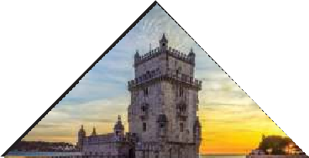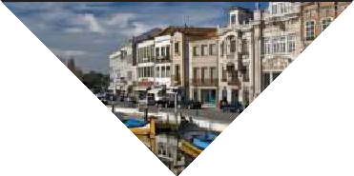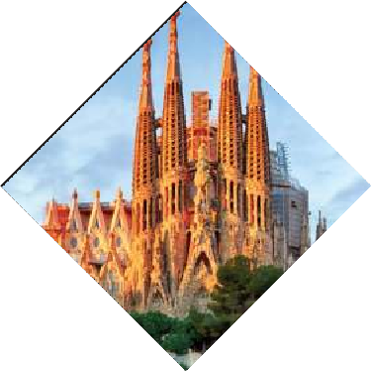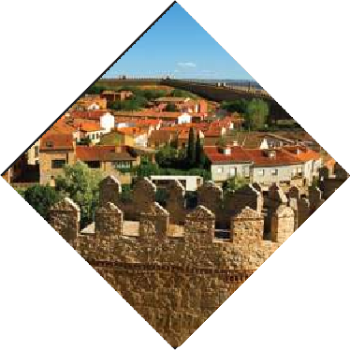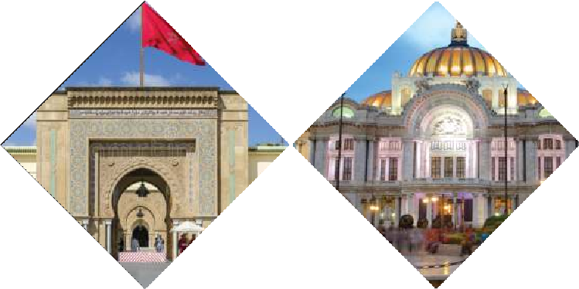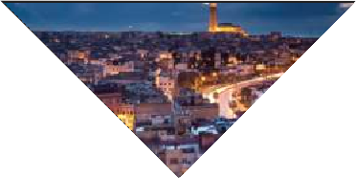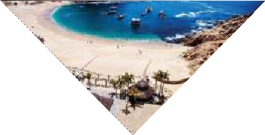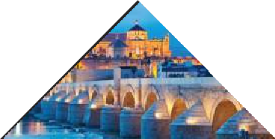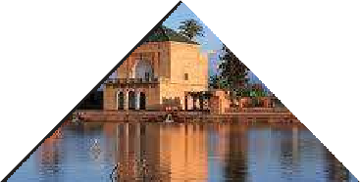

**-:** **Inclusions** **:-**



Return Economy Class Air Ticket with Taxes Ex-Kolkata Economy class Air Fare for the internal sectors as per itinerary All tours & transfers by Deluxe Coach

English speaking local Guide services as per itinerary

All Taxes & Service Charges as mentioned in the itinerary Overseas Medical & Travel Insurance up to 60 years of age Tips for Overseas Tour Guides & Coach Drivers

Service of a Tour Manager from Kolkata throughout the tour

**-:** **Exclusions** **:-**



Government of India Goods & Services Tax (GST) of 5% TCS 5% applicable on total tour Package (incl. of all taxes). Extra amount Insurance for 60 years and above

Any extra cost incurred due to illness, accident, hospitalization, or any personal emergency.

Any extra expense incurred due to any force majeure situation before Any extra expense incurred due to any force majeure situation before

Passport related services

Personal expense like porterage, laundry, telephone, shopping, alcoholic beverages, extra mineral water, or food which is not a part of group’s set meal plan,

Anything specifically not mentioned in the ‘package includes’ column. Any increase in Taxes if imposed by Airline/Govt./Visa Authorities

**-:** **Disclaimer** **:-**

**The** **itinerary,** **tour** **price** **&** **hotels** **are** **subject** **to** **change** **under** **unavoidable** **circumstances** **without** **prior** **notice.**

**-:** **Payment** **Terms** **:-**

### **Registration Fees: Rs. 50,000/- Per Person. Balance payable 6 weeks prior to departure.

N.B. All pricing is based on minimum group size of 20 adults and worked out as per rates available on 1st January 2025 which are subject to change without notice if such rates change prior to departure. Airfare & Airline is subject to change as per availability & due to situations beyond our control.

 **ED-24,** **Rajdanga** **Main** **Road,** **E.K.T.** **Kolkata** **-** **700107** [**www.travroamholidays.com**](http://www.travroamholidays.com/)

**Prasanta** **98300** **73383**



**Shouvik** **96742** **83977**

**Debnath** **98368** **97872**

**Sonali** **97481** **32975**

**Mousumi** **83349** **02894**