holidays
tra roam
The Great Escape

South Africa
with Victoria Falls
14 Days

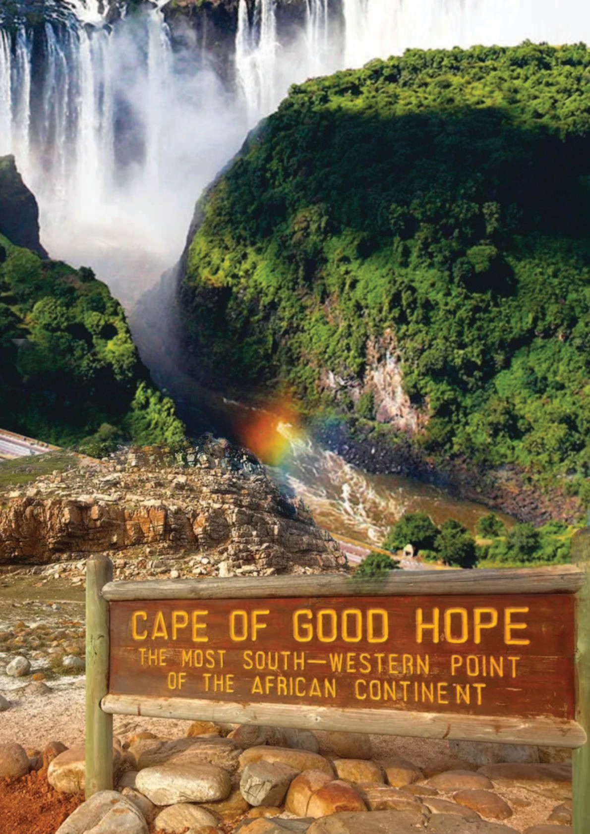

Group Departure
20th May, 18th Oct 2026

Lying towards the southern edge of Africa, South Africa is an ultimate destination for a vacation. The South Africa tour includes an excursion to the magnificent mountains, the Wineland, the beaches, game reserves and a lot more. South Africa is known worldwide for the dark political past and the struggles. Today the cities of South Africa have developed with several eateries andcafé in the water- front region. Explore the panoramic gateway as Garden route cities and the Cape Wineland. Knysna and Oudtshoorn are the destinations where you can enjoy some thrilling adventure along with the picturesque beauty. Victoria fall While it is neither the highest nor thewidest waterfall in the world, it is classified as the largest, based on its width of 1,708 metres (5,604ft) and height of 108 metres (354 ft), resulting in the world's largest sheet of falling water. VictoriaFalls is roughly twice the height of North America's Niagara Falls and well over twice the width ofits Horseshoe Falls. In height and width Victoria Falls is rivalled only by Argentina and Brazil's IguazuFalls. Book your South Africa Tour with Victoria Falls Package Now.
-: PLACES COVERED :-
Capetown Mossel Bay Oudtshoorn Knysna Johannesburg Kruger National Park
Zambezi River Cruise Zambezi National Park Victoria Falls

-: Detailed Itinerary :-
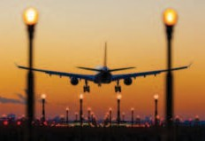

DAY KOLKATA TO CAPE TOWN
1 Today you begin your journey by boarding your outbound flight for Cape Town. The tour of South Africa is always a dream of those travellers who are always wants to explore the new one so we are trying to fulfill their dreams with our
sincerity.

[ Meals on Board ]
ARRIVE CAPE TOWN DAY
Upon arrival in Cape Town, drive to Two Oceans Aquarium. The Two Oceans Aquarium is a marine life 2
attraction in Cape Town, South Africa, located at the V&A Waterfront. It features over 8,000 marine
animals from the Indian and Atlantic Oceans. Later we proceed to Capetown city tour including this tour we’ll visit Bo-Kaap. Then transfer to hotel check-in dinner & overnight at Cape Town.
[ Meals on Board & Dinner ]

DAY CAPE TOWN
3 Post breakfast leave for Table Mountain known as New 7 Wonder of Nature. A both way cable car ride
takes you to the top of Table Mountain (depends on Weather condition otherwise Signal Hill) for a breath
-taking view over the city. Then will take Helicopter Tour – you can enjoy breathtaking view of Cape Town city & Atlantic Ocean from the Sky. Post lunch proceed to Robben Island.(Subject to weather conditions) The island has a long and fascinating history, and it is now home to a variety of attractions. See the prison where Nelson Mandela was held. There are also plenty of opportunities to see wildlife, including penguins and endemic bird. Evening You can do some souvenir shopping from the famous V A Waterfront. Over night stay at Cape Town.
[ Breakfast, Light Lunch & Dinner ]

CAPE TOWN – CAPE PENINSULA – CAPE TOWN DAY
After breakfast depart on a full day Peninsula tour. This comprehensive tour shows you the best of the 4 spectacular Cape Peninsula and why it is it's called the Fairest Cape. You will travel through Camps Bay, Chapman's Peak & Simon’s Town known as one of the beautiful scenic roads of the world. We will take
Seal Island Cruise from Hout Bay followed by Visit the beautiful Boulders Beach where you can spot African Jackass Penguins. Later you will take to the Cape of Good Hope Nature Reserve including Cape Point Light House & Cape of Good Hope. Enjoy the funicular ride aboard the “Flying Dutchman” and enjoy the unforgettable spectacular views. Return to the hotel for Overnight stay.
[ Breakfast, Light Lunch & Dinner ]
DAY CAPETOWN – KNYSNA LAGOON CRUISE – MOSSEL BAY
5 Post breakfast, checkout from Cape Town Hotel & drive towards Knysna. The road from Cape Town to
Knysna is a part of South African Farmlands – you can spot farms/gardens throughout the journey till Knysna. Upon arrival Knysna, take a cruise on the vast Knysna Lagoon. Enjoy an amazing view of the imposing sandstone‘Heads’ which guard the sea entrance to Knysna’s huge tidal lagoon, and the forests, marshes and pristine beaches surrounding it. Later, check-in into the hotel for overnight stay.
[ Breakfast & Dinner ]


MOSSEL BAY – OUDTSHOORN – MOSSEL BAY
DAY
6
After breakfast drive to Oudtshoorn. It is known as the ‘Feather Capital of the World’ thanks to its huge ostrich industry. Visit & enjoy guided tour of the Cango Caves one of the world’s great natural wonders, sculptured by nature through the ages fascinating limestone formations in a wide variety of
colours. Next visit & enjoy a guided tour of Ostrich Farm. Come face to face with the biggest bird in the world. Next enjoy guided tour of the Wildlife Ranch where you will get an opportunity to encounter with wild animals (if situation permits).
[ Breakfast, Lunch & Dinner ]


DAY MOSSEL BAY – GEORGE – JOHANNESBURG – KRUGER NATIONAL PARK
7 Early morning transfer to George airport to board a flight to Johannesburg. On arrival at Johannesburg
transfer to Kruger National Park. The national park is the king of South Africa game parks and one of the best game viewing areas in all of Africa. Overnight stay at Kruger.
[ Breakfast, Light Lunch & Dinner ]
KRUGER NATIONAL PARK – FULL DAY GAME DRIVE DAY
Early morning proceeds for full day game drive in the Kruger National Park to explore the Big Five. It 8 certainly fulfils most visitors’ fantasies of seeing magnificent herds of game roaming across studded stretched of savanna land is the home to Big Five. The park is over 60kms wide & 350kms long. After a
day full of explorations, proceed for overnight at hotel.
[ Breakfast, Lunch & Dinner ]

DAY KRUGER NATIONAL PARK TO JOHANNESBURG

9 After breakfast transfer to Johannesburg. Upon arrival proceed for an orientation tour of Johannesburg. Check in to hotel and overnight in Johannesburg.
DAY
10

[ Breakfast, Lunch & Dinner ]

JOHANNESBURG - VICTORIA FALLS - SUNSET CRUISE

After breakfast check out & transfer to O R Tambo International airport from fly to Victoria Falls. Welcome to Victoria Falls. Victoria Falls is a waterfall on the Zambezi River in southern Africa, on the border of Zambia and Zimbabwe. It's one of the world's largest waterfalls and is known as "The Smoke that Thunders". In the evening settle into a relaxing sunset cruise at Zambezi River amidst the wildlives specially Hippos and take partin one of the most celebrated moments of the day, watching the African sun sink below the horizon in a splash of colours across the skyline. Dinner & Overnight.
[ Breakfast, Meals on Board & Dinner]


DAY ZAMBEZI NATIONAL PARK GAME DRIVE – VICTORIA FALLS
11 Early morning proceeds for a game drive in Zambezi National Park, a 57,000-hectare unfenced National Park, home to elephant, buffalo, lion, leopard, and several species of plains game including kudu, impala, and bush buck. The Zambezi River marks its northern border, beyond which lies Zambia. After
Lunch visit to Victoria Falls National Park for guided tour of the largest waterfalls of the World. Victoria Falls is roughly twice the height of North America's Niagara Falls and well over twice the width of its Horseshoe Falls. In height and width Victoria Falls is rivalled only by Argentina and Brazil's Iguazu Falls. we walk through Victoria Falls bridge to experience the largest Victoria Falls from Zambia Side.
Overnight in Victoria Falls.
[ Breakfast, Lunch & Dinner ]

VICTORIA FALLS - JOHANNESBURG DAY
After breakfast, check out & transfer to airport from fly to Johannesburg. Check in hotel Dinner & over 12
night.
[ Breakfast, Meals on Board & Dinner ]
DAY DEPARTURE

13 After breakfast check out & transfer to O R Tambo International for flight back to home with a heart full of precious memories of the dreamy South Africa with Victoria Falls.

[ Breakfast, Meals on Board ]

ARRIVE KOLKATA
DAY

Tour Ends. 14
[ Meals on Board]

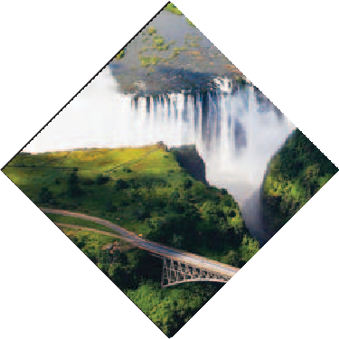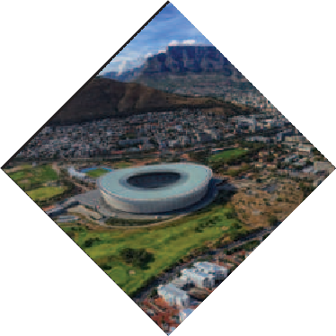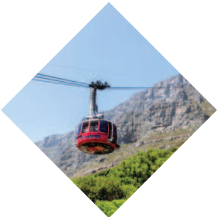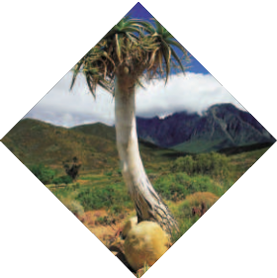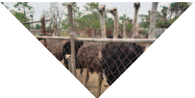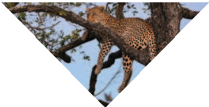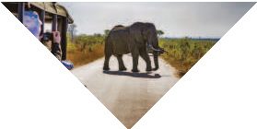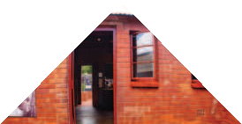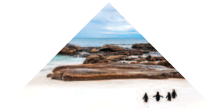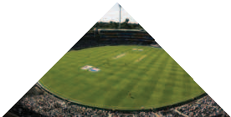

-: Package price :-
PRICE FROM
ADULT (TWIN/DOUBLE SHARE)
CHILD [2-11 Years]
WITH BED
CHILD [2-5 Years]
WITHOUT BED
SINGLE SUPPLEMENT
TRIPLE REDUCTION
KOLKATA

TBA
TBA
TBA
TBA

-: Inclusions :-
Return Economy Class Air Ticket Ex- CCU (Kolkata) 3*/4* Hotels on Twin/Double Sharing basis
Meals as specified in the programme.
All tours & transfers by Air-Conditioned Deluxe Coach South African Tourism Development Levy
English speaking local Guide services as per Programme Overseas Medical & Travel Insurance upto 60 years
Visa Processing Charges (As on 27th June 2025) Service of a Tour Leader from Kolkata.
Tips for Overseas Tour Guides & Coach Drivers

-: Exclusions :-
GST 5% on the total tour price including the optional tours if any. TCS 5% applicable on total tour Package (incl. of all taxes).
Extra amount Insurance for 60 years and above Porterage
Any extra expense incurred due to any force majeure situation before the tour departure or
during the tour.
Any extra cost incurred due to illness, accident, hospitalization, or any personal emergency. Passport related services
Personal expense like porterage, laundry, telephone, shopping, alcoholic beverages, extra
mineral water, or food which is not a part of group’s set meal plan, Anything specifically not mentioned in the ‘package includes’ column. Any increase in Taxes if imposed by Airline/Govt./Visa Authorities
City Tax

-: Disclaimer :-
The itinerary, tour price & hotels are subject to change under unavoidable circumstances without prior notice.

-: Payment Terms :-

**Registration Fees: Rs. 50,000/- Per Person. Balance payable 6 weeks prior to departure.
N.B. All pricing is based on minimum group size of 20 adults and worked out as per rates available on 01st Nov 2025 which are subject to change without notice if such rates change prior to departure. Airfare & Airline is subject to change as per availability & due to situations beyond our control.

 ED-24, Rajdanga Main Road, E.K.T. Kolkata - 700107 www.travroamholidays.com

Prasanta 98300 73383
Shouvik 96742 83977
Debnath 98368 97872

Sonali 97481 32975
Mousumi 83349 02894




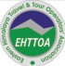
holidays
tra roam

