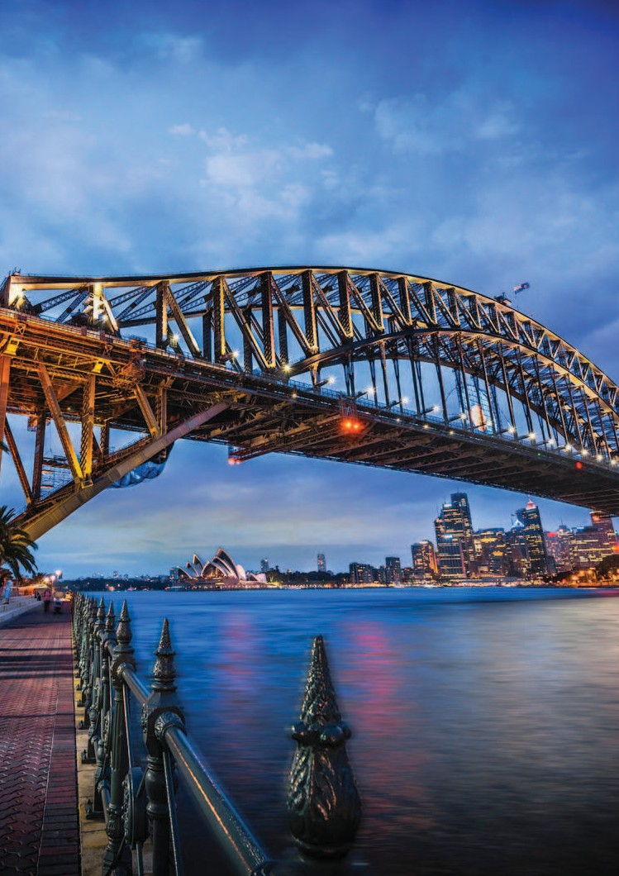












holidays
tra roam

Land of Kiwi & Kangaroo
(Australia & New Zealand)
16 Days
[EX-Kolkata]

Departure Dates 17th May, 25th Oct 2026

Countries/Cities Covered:
Australia
Melbourne, Sydney, Cairns
New Zealand
Auckland, Waitomo, Rotorua, Queenstown, Milford Sound, Christchurch, Mt. Cook, Twizel, Fox Glacier
-: HOTEL ACCOMMODATIONS :-

MELBOURNE SYDNEY CAIRNS AUCKLAND ROTORUA QUEENSTOWN
TWIZEL
Holiday Inn Express Little Collins or similar Holiday Inn Potts Point or similar
Hotel Pacific Cairns or similar
Auckland City hotel or similar Ibis Rotorua Hotel or similar
Holiday Inn Queenstown Remarkables Park or similar
Distinction Mackenzie Country Hotel or similar

FOX GLACIER Heartland Hotel Glacier Country or similar

CHRISTCHURCH
Quality Hotel Elms or similar

-: Detailed Itinerary :-

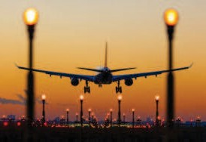

DAY DEPART KOLKATA
1 Today you begin your journey by boarding your outbound flight to Melbourne.
[Dinner on Board]


ARRIVE MELBOURNE
DAY
2
Upon reaching Melbourne complete the immigration process. Melbourne - is the capital and most populous city in the state of Victoria, and the second most populous city in Australia. Good food, good Wine & fresh produce add to the Tourist attraction. Meet on arrival & transfer for Dinner before Check-in. Overnight at Melbourne.
[Meals on Board & Dinner]


DAY MELBOURNE – PHILLIP ISLAND
3 Enjoy Half Day Melbourne City tour covering city centre of Melbourne. Here is the opportunity, to see
the sporting complexes, Melbourne Cricket Ground (MCG), Fitzroy Gardens, Captain Cook’s Cottage (Out side) and Shrine of Remembrance. Afternoons proceed to Phillip Island Tour famous for World smallest penguins. Visit Summerland Beach to witness some penguin magic.
[Breakfast, Light/Packed Snacks & Dinner]


MELBOURNE – DAY TRIP TO GREAT OCEAN ROAD
DAY
4
Today after breakfast, we will proceed for a daytrip to Great Ocean Road, near the coast to view the
12 Apostles. The Great Ocean Road trip will show the beauty of this coastal drive and take you through pristine beaches, fresh rainforest, and rugged limestone rock formations. Be wowed by the 12 Apostles – these iconic rock formations lie just off the shore of Port Campbell National Park in Victoria. Get lost in the beauty of this natural scenery. After a full day of exploring, we say goodbye to the Great Ocean Road and turn back inland to drive back to Melbourne via country roads. Dinner & Overnight.
[Breakfast, Light/Packed Snacks & Dinner]


DAY MELBOURNE – CAIRNS
5 Post Breakfast Transfer to airport for flight to Cairns. On arrival at Cairns meet & transfer to hotel. Free

time. Dinner & overnight at Cairns.
[Breakfast, Light/Packed Snacks & Dinner]

CAIRNS


DAY
6

Enjoy Full Day Big Cat Green Island Reef Cruise with Lunch. Go for a Snorkel, explore the amazing corals under the watchful eyes of lifeguards or enjoy a Semi-Submersible Coral Viewing Tour. It’s just another day in Paradise. Dinner & overnight at Cairns.
[Breakfast, Light/Packed Snacks & Dinner]

DAY CAIRNS - SYDNEY
7 Transfer to airport for flight to Sydney. On arrival at Sydney Enjoy Half Day Sydney City tour covering
Darling Harbour, Sydney Harbour Bridge etc. Later, proceed for a guided tour of Sydney Opera House. Evening Enjoy Sydney Showboat Cruises with Dinner. Overnight at Sydney.

SYDNEY DAY
Today go for a full day tour to Blue Mountain & Wildlife Park. Visit Echo Point, to see the Three Sisters 8
rock formation towering over Jamieson Valley. Discover the “Grand Canyon” of giant rock formation. Visit Sydney Zoo – hand feed Kangaroos, see Koalas in trees and close-up. Overnight at Sydney.
[Breakfast, Light/Packed Snacks & Dinner]


DAY SYDNEY - AUCKLAND
9 Transfer to Sydney airport for departure flight to Auckland. On arrival at Auckland, visit the Auckland
Sky Tower. A dizzying 1,076 feet (328 meters) high, the Auckland Sky Tower is not only New Zealand’s highest building but also the tallest man-made structure in the Southern Hemisphere. The tower offers unbeatable views of Auckland’s skyline, with its distinctive spire visible from all corners of the city. Check in Hotel. Dinner & overnight at Auckland.
[Breakfast, Light/Packed Snacks & Dinner] AUCKLAND – WAITOMO – ROTORUA DAY
Visit world famous Waitomo Glowworm Caves. Proceed to Rotorua. En route visit Te Puia Geothermal 10
Reserve to view the boiling mudpools & cascading pohutu geyser & see local Maori carvers in action. On arrival check-in Hotel. Dinner & overnight at Rotorua.
[Breakfast, Light/Packed Snacks & Dinner]
DAY ROTORUA – CHRISTCHURCH - TWIZEL
11 Post Breakfast visit the Agrodome Farm show including Sheep Shearing. Witness a live sheep
shearing demonstration and the remarkable farm dogs as they demonstrate their ability to respond to commands and keep those sheep in line. Transfer to airport for departure flight to Christchurch. On arrival meet & transfer for an orientation city tour of Christchurch. Christchurch, a lush patchwork of flat, green farmlands surrounds you as you traverse some of the most impressive braided rivers in the world. Enroute visit Lake Tekapo the Church of The Good Shepherd, sitting solitary at the edge of the vivid blue lake, offers a popular photo opportunity. Then transfer to Twizel. Overnight in Twizel.
[Breakfast, Light/Packed Snacks & Dinner]


TWIZEL- MT. COOK - QUEENSTOWN
DAY
12
tra roam
After Breakfast. Check out. Continue on the spectacular scenic drive through dramatic and vast landscapes to a rugged land of ice and rock, home to New Zealand’s highest mountain, Aoraki Mt Cook. Mount Cook National Park is a national park located in the Canterbury Region in the central-west of the South Island of New Zealand. Later transfer to Queenstown. The fascinating towering pinnacles of the Clay Cliffs are situated just before Oramama where you will take the southern route through the beautiful and dramatic Lindis Pass. The journey then whisks you alongside lakes and rivers through Cromwell, a historic mining town known for its stone fruit, to the sophisticated resort town of Queenstown. Arrive Queenstown and proceed with sightseeing covering Gondola Ride. Take in the stunning views as you ride the Skyline Gondola cable car to the top of Bob’s Peak above Queenstown and Lake Wakatipu for a spectacular
220-degree panorama with breath-taking views. Overnight stay at Queentown.
[Breakfast, Light/Packed Snacks & Dinner]

DAY QUEENSTOWN - MILFORD SOUND – QUEENSTOWN
13 Enjoy full day tour to world famous Milford Sound including cruise. A full-length cruise of Milford
Sound in modern, purpose-built vessels offers magnificent views of the Mitre Peak and Bowen Falls. Lunch on board. Back to Queenstown. Dinner & overnight in Queenstown.
[Breakfast, Light/Packed Snacks & Dinner]


QUEENSTOWN – FOX GLACIER (GLACIER REGION)
DAY
14
After breakfast, check-out from the hotel at Queenstown and proceed towards Franz Josef. Enjoy waterfalls and river scenery on the drive up the West Coast, a wild and untamed place famous for its rivers, rainforests, glaciers and geological treasures. At the Gates of Haast, a series of rapids creates a waterfall effect as the racing glacial waters thunder below the road. Continue on a spectacular scenic drive through the lush temperate rainforest to the glacier regions of Fox and Franz Josef, relics of the last ice age and among the most convenient in the world to visit.
[Breakfast, Light/Packed Snacks & Dinner]

DAY FOX GLACIER – GREYMOUTH - CHRISTCHURCH
15 After breakfast, proceed to Greymouth Railway Station to board the TranzAlpine scenic train
(Optional Tour) from Greymouth to Christchurch. This is considered to be one of the most scenic train journey routes in New Zealand. Described as one of the great train journeys in the world, the TranzAlpine travels from coast to coast across the mountainous spine of the South Island past aqua blue rivers and through vast patchwork plains. On arrival Christchurch transfer to hotel for Overnight.
[Breakfast, Light/Packed Snacks & Dinner]
DEPARTURE DAY
Post Breakfast transfer to ChristChurch Airport for your return flight to Kolkata. Arrive at Kolkata with 16
a heart full of precious memories of the dreamy Australia & New Zealand.Tour Ends.
[Packed Breakfast & Meals on Board]

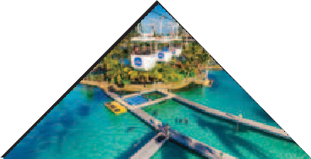
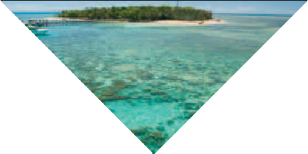
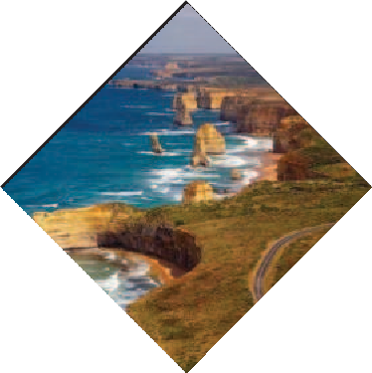
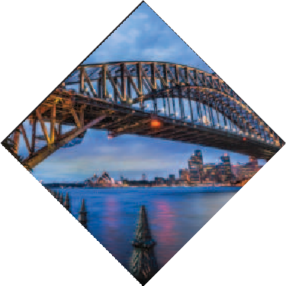
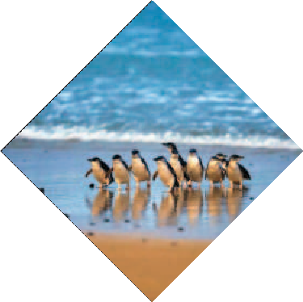
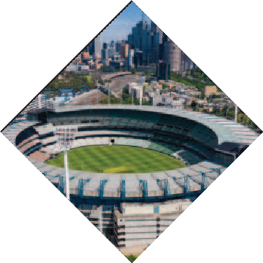
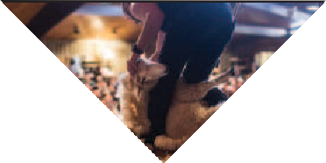
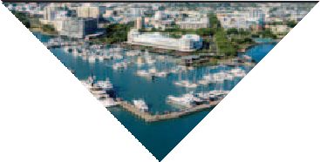
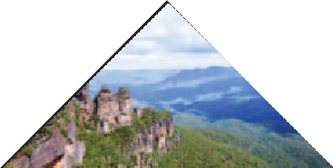
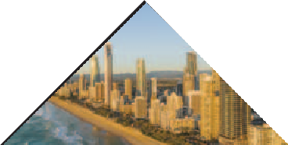


holidays

Package price
PRICE FROM
ADULT (TWIN/DOUBLE SHARE)
WITH BED
CHILD [2-11 Years]
CHILD [2-5 Years]
WITHOUT BED
SINGLE SUPPLEMENT
TRIPLE REDUCTION

**Optional Tour - TranzAlpine scenic train tour (Price - TBA)
TBA
TBA
KOLKATA

-: INCLUDES :-
Return Economy Class Air Ticket Ex- CCU (Kolkata) 4* / 3* Hotels on Twin/Double Sharing basis
Meals as specified in the programme.
All tours & transfers by Air-Conditioned Deluxe Coach English speaking local Guide services as per Programme
All Taxes, Entrance Fees & Service Charges as mentioned in the itinerary Overseas Medical & Travel Insurance upto 60 years
Airport Taxes (As on 27th Jun 2025)
Visa Processing Charges (As on 27th Jun 2025) Service of a Tour Leader from Kolkata.

-: Exclusions :-
Government of India Goods & Services Tax (GST) of 5% TCS 5% applicable on total tour Package (incl. of all taxes). City Tax/Resort fees.
Extra amount Insurance for 60 years and above
Any extra cost incurred due to illness, accident, hospitalization, or any personal emergency. Any extra expense incurred due to any force majeure situation before Any extra expense incurred due to any force majeure situation before
Passport related services
Personal expense like porterage, laundry, telephone, shopping, alcoholic beverages, extra mineral water, or food which is not a part of group’s set meal plan,
Anything specifically not mentioned in the ‘package includes’ column. Any increase in Taxes if imposed by Airline/Govt./Visa Authorities

-: Disclaimer :-
The itinerary, tour price & hotels are subject to change under unavoidable circumstances without prior notice.

-: Payment Terms :-

**Registration Fees: Rs. 1,00,000/- Per Person. Balance payable 6 weeks prior to departure.
N.B. All pricing is based on minimum group size of 20 adults and worked out as per rates available on 27th Jun 2025 which are subject to change without notice if such rates change prior to departure. Airfare & Airline is subject to change as per availability & due to situations beyond our control.

 ED-24, Rajdanga Main Road, E.K.T. Kolkata - 700107

www.travroamholidays.com

Prasanta 98300 73383
Shouvik 96742 83977
Debnath 98368 97872

Sonali 97481 32975
Mousumi 83349 02894




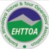
holidays
tra roam

