holidays
Alaskan Wilderness 17 Days

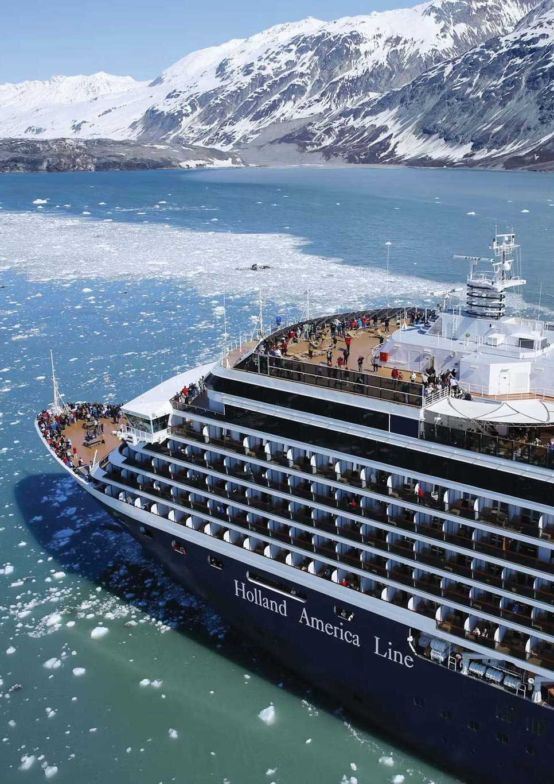



tra roam

Group Departure
25th May

2026

-: Tour Highlights :-
Vancouver : Half day Guided tour including Visit Stanley Park, West Coast Native Totem Poles, English Bay, Gastown

Alaska Cruise : Vancouver, Tracy Arm, Juneau, Skagway, Glacier Bay, Ketchikan
Canadian Rockies : Vancouver, Fraser Valley, Evening boat cruise with dinner on Okanagan Lake, Kamloops, Roger’s Pass, Lake Louise,
Banff, Icefield Parkway, Sulphur Mountain Gondola, Columbia Icefields, Wellsgray Park, Spahat’s Falls & Dutch Lake, Othello Tunnels, Jasper, Valemont,
Meals : All meals on board Cruise Daily Breakfast & Dinner in package

-: Detailed Itinerary :-
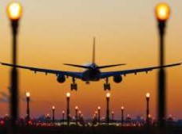

DAY DEPART KOLKATA
1 Today you begin your journey by boarding your outbound flight to Vancouver.
[ Meals on Board ]


ARRIVE VANCOUVER DAY
Meet on arrival at Vancouver. Then half day Guided tour of Vancouver – “Gateway of the Pacific”. Enjoy 2
the natural beauty, cosmopolitan flavor and diversity of experiences of Vancouver. Visit Stanley Park,
West Coast Native Totem Poles, English Bay, Gastown and other popular sights. Then transfer to hotel Check in Dinner & Overnight.
[ Meals on Board & Dinner ]

DAY VANCOUVER
3 Breakfast. Transfer to British Columbia Port to connect 7 nights / 8 days Alaska Cruise. The perfect
combination of urban meets nature, Vancouver is a hub for lovers of the great outdoors. Enjoy picturesque views of the mountains while exploring the city’s local hot spots like Stanley Park, Granville Island, Gastown and more. Don’t forget to sample the best of the local culinary and cocktail scene for something truly unique. Here’s how to enjoy a stop at Hollywood of the North.
[ Breakfast & Meals on Board ]


SCENIC CRUISING THE INSIDE PASSAGE
DAY
4
Alaska's Inside Passage is a renowned cruising route through a protected network of waterways, featuring glacier-cut fjords, lush rainforests, and diverse wildlife. Stops along the route showcase Alaska's rich history, including Native Alaskan culture in Ketchikan and Skagway's Gold Rush era legacy. Here's how to experience the best of the Inside Passage.
[ Meals on Board ]


DAY TRACY ARM INLET
5 Steep cliffs and glacier-covered mountains flank this fjord, fringed by the largest intact coastal
temperate rain forest in the United States. Old-growth trees colonized Tracy Arm's mouth long ago as the Ice Age retreated. But further up the sinuous 48-kilometer (30-mile) waterway, its icy grip lingers a little.
There, the twin Sawyer Glaciers flow from the peaks down to the sea, sloughing off stories-high chunks of water frozen decades or even centuries before. Even more glorious than nearby Glacier Bay, Tracy Arm is part of the 5.7 million acres (or around 23,000 square kilometers) of pure wilderness sheltered by the Tongass National Forest (America's biggest). Visitors often see bears, whales and mountain goats roaming across various corners of this pristine area—not to mention chubby baby seals resting on the ice floes.

Summer temperatures average 35 to 60 degrees Fahrenheit (0 to 16 degrees Celsius), so pack warm clothing. And don';t forget waterproof gear, even when traveling by cruise ship: More than a meter and a half of rain falls here each year! We also recommend a water bottle, thermos or reusable coffee cup: On scenic cruising days, cruise ships ban paper and disposable plastic products that could litter this unsullied environment.
DAY
6

[ Meals on Board ]

SKAGWAY

Set sail on an Alaska Cruise and take an adventure in Skagway. At every turn, you’ll find yourself immersed in gold rush lore, from the infamous Red Onion Saloon that still keeps a pistol that Wyatt Earp left behind en route to the Klondike, to the White Pass & Yukon Route Railroad, a classic narrow- gauge railway that traverses rugged mountains and passes cascading waterfalls and towering glaciers as it connects Skagway to Whitehorse deep in the Yukon. Known as the "Garden City of Alaska," Skagway is filled with beauty and nature. Explore the town on a Skagway excursion. Much of the town has been preserved as part of the Klondike Gold Rush National Historical Park, where rangers offer free walking tours around the historic district. Take an Alaska Cruise to Skagway and you’ll also find a vibrant local community, home to a rich collection of local galleries, curio shops and restaurants serving seafood plucked fresh from nearby waters.
[ Meals on Board ]

DAY GLACIER BAY
7 On your cruise to Glacier Bay, close your eyes and take in the sounds—the creaks and groans
of “living” ice, the shrill cries of gulls and soaring eagles, the splash of a breaching humpback whale. Frosted peaks towering over mossy forests, wide tidewater glaciers (there are seven in the park), and marine wildlife are givens on Glacier Bay cruises, but every experience in this changing biosphere is unique.

Glacier Bay National Park & Preserve is best explored on an Alaska Cruise or an Alaska Land+ Sea Journey cruise tour. Our ships are perfectly sized for the optimal experience. Prepare for inclement weather, even in summer and dress for rain. Pack a hat, gloves, wool or fleece layers, a warm coat and waterproof gear to comfortably admire the landscape from the open deck of your ship. There are glaciers, fjords, inlets, rivers, streams and wildlife galore on Glacier Bay cruises, so bring those binoculars.
DAY
8

[ Meals on Board ]

KETCHIKAN

Ketchikan has long been an important hub of the salmon-fishing and -packing industries. Visitors
can try their luck on a sportfishing or simply savor the fresh seafood at one of the local restaurants on a cruise to Ketchikan excursion. Ketchikanis also one of the best spots along the Inside Passage to explore the rich cultural sights of Native Alaskan nations like the Tlingit, Haida and Tsimshian. You can see intricately carved totem poles at the Totem Heritage Center and Totem Bight State Park, while the attractions of Saxman Village just outside of Ketchikan offers the chance to see Tlingit culture in action, with working carvers and a dance show in the clan house. On an Alaska cruise to Ketchikan don't forget to leave time to explore the sights in the town itself, including historic Creek Street, a boardwalk built over the Ketchikan Creek, where you can shop for souvenirs, smoked salmon and local art, while exploring gold rush–era tourist attractions like Dolly’s House Museum.
[ Meals on Board ]

DAY SCENIC CRUISING THE INSIDE PASSAGE
9 Alaska's Inside Passage is a renowned cruising route through a protected network of
waterways, featuring glacier-cut fjords, lush rainforests, and diverse wildlife. Stops along the route showcase Alaska's rich history, including Native Alaskan culture in Ketchikan and Skagway's Gold Rush era legacy. Here's how to experience the best of the Inside Passage.
[ Meals on Board ]


VANCOUVER - KELOWNA
DAY
10
Arrive at Vancouver British Columbia Port. Travel through the Fraser Valley to Okanagan.
Visit the famous wineries and fruit farms. Evening boat cruise with dinner on Okanagan Lake. Check into your hotel at Kelowna. Overnight.
[ Breakfast & Dinner ]

DAY KELOWNA – LAKE LOUISE – BANFF
11Breakfast. Travel through Vermon Stop at Roger’s Pass. Proceed to Lake Louise – Canada’s “Diamond in the Wilderness” and “Hiking Capital of Canada”. Sightseeing at Lake Louise. Proceed to Banff. Check in hotel. Dinner & overnight.
[ Breakfast & Dinner ]

FULL DAY SIGHTSEEING OF BANFF NATIONAL PARK & NEARBY PLACES DAY
Breakfast. Discover the Canadian Rockies favorite resort town and its beautiful environment 12 on a tour of Banff. Visit the intriguing hoodoos earth pillars shaped by centuries of wind, the spot where Banff’s history began. Ride Sulphur Mountain on the Banff Gondola.
[ Breakfast & Dinner ]

DAY BANFF – JASPER – VALEMONT
13 Breakfast. Travel the scenic Icefields Parkway. Visit the Columbia Icefield Skywalk. Tour through Jasper National Park. Dinner & overnight stay at Valemount.
[ Breakfast & Dinner ]

VALEMOUNT- WELLSGRAY PARK – KAMLOOPS DAY
Morning go on a Bear Safari Tour. Tour through Wellsgray Park with a stop at Spahat’s Falls 14
and Dutch Lake. Spend some time the lush alpine meadows with opportunities for excellent birding and wildlife viewing. Proceed to Kamloops. Check in hotel. Dinner & overnight.
[ Breakfast & Dinner ]


DAY KAMLOOPS – COQUIHALLA CANYON PROVINCIAL PARK - VANCOUVER
15 Depart for Vancouver. Enroute visit Othello Tunnels, also known as the Quinette Tunnels. Check in hotel. Dinner & Overnight.

[ Breakfast & Dinner ]

DEPARTURE
DAY


DAY

ARRIVE KOLKATA
After Breakfast transfer to Vancouver Airport for Final Departure. 16
[ Breakfast & Meals on Board ]

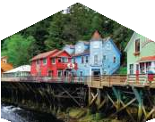
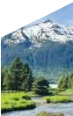
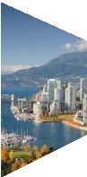
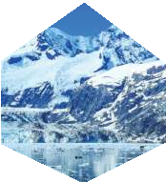
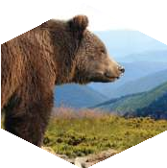

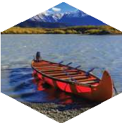

17 Arrive Kolkata. Tour Ends.
-: Package price :-
[Cruise Accommodations - Inside Cabin]
PRICE FROM
Ex - KOLKATA
ADULT
(TWIN/DOUBLE SHARE)

CHILD [2-11 Years]
WITH BED

TBA
CHILD [2-5 Years]
WITHOUT BED
TBA
SINGLE SUPPLEMENT
TBA
TRIPLE REDUCTION

TBA

-: Inclusions :-
Return Economy Class Air Ticket with Taxes Ex-Kolkata. 3*/4* Hotels on Twin/Double Sharing basis.
meals as per itinerary.
All Sightseeing & Entry Fees as per itinerary.
English speaking local Guide services as per itinerary. Overseas Medical & Travel Insurance up to 60 years of age.
Visa Processing Charges.
Service of a Tour Manager from Kolkata throughout the tour.
-: Exclusions :-
Government of India Goods & Services Tax (GST) of 5% TCS 5% applicable on total tour Package (incl. of all taxes). Extra amount Insurance for 60 years and above
Any extra cost incurred due to illness, accident, hospitalization, or any personal emergency.
Any extra expense incurred due to any force majeure situation before Any extra expense incurred due to any force majeure situation before
Passport related services
Personal expense like porterage, laundry, telephone, shopping, alcoholic beverages, extra mineral water, or food which is not a part of group’s set meal plan,
Anything specifically not mentioned in the ‘package includes’ column. Any increase in Taxes if imposed by Airline/Govt./Visa Authorities
Tips
Shore excursions dose not include
Note : Visa Charges as per now
-: Disclaimer :-
The itinerary, tour price & hotels are subject to change under unavoidable circumstances without prior notice.
-: Payment Terms :-

**Registration Fees: Rs. 1,00,000/- Per Person. Balance payable 6 weeks prior to departure.
N.B. All pricing is based on minimum group size of 20 adults and worked out as per rates available on 01st Sep 2025 which are subject to change without notice if such rates change prior to departure. Airfare & Airline is subject to change as per availability & due to situations beyond our control.
 ED-24, Rajdanga Main Road, E.K.T. Kolkata - 700107 www.travroamholidays.com

Prasanta 98300 73383
tra roam
Shouvik 96742 83977
Debnath 98368 97872





Sonali 97481 32975
Mousumi 83349 02894


holidays

